|  |
| --- |
| Disability Worker Regulation Scheme |
| Regulatory approach  Accessible |

Who we are 1

What we regulate 2

Who we regulate 2

Our co-regulators and partners 3

Our desired regulatory outcomes 3

Our harms of concern 3

Our expectation of disability workers 4

Our regulatory principles 4

Our regulatory approach 5

Our risk-based approach 8

How we prioritise and allocate regulatory effort – our risk-based approach 8

Our regulatory toolkit 10

Our enforcement approach 12

Reviews and appeals of regulatory decisions 14

Avenues for review of our regulatory decisions 14

Opportunities for internal review 14

Our accountability 14

List of co-regulators and partners 15

Transparency 16

# Who we are

The Victorian Disability Worker Commission (Commission) and the Disability Worker Registration Board of Victoria (Board) regulates disability workers who provide services to people with disability in Victoria.

We are an independent statutory authority and ministerial appointed registration board established under the Disability Service Safeguards Act 2018 (DSS Act)to reduce the risk of neglect and abuse of people with disability and improve the quality of disability care and service by ensuring workers are appropriately skilled and qualified. Although the DSS Act establishes us as distinct legal entities, the Commission, the Board and the Victorian Disability Worker Commissioner (Commissioner) work together to regulate disability workers in Victoria. We aim to carry out our functions in a way which upholds these objectives and is in accordance with our values of:

* diversity and inclusion
* independent and fair
* fearless and accountable
* trust and respect
* empathy and dignity.

Figure 1: Interrelationships between the Commission, the Commissioner and the Board

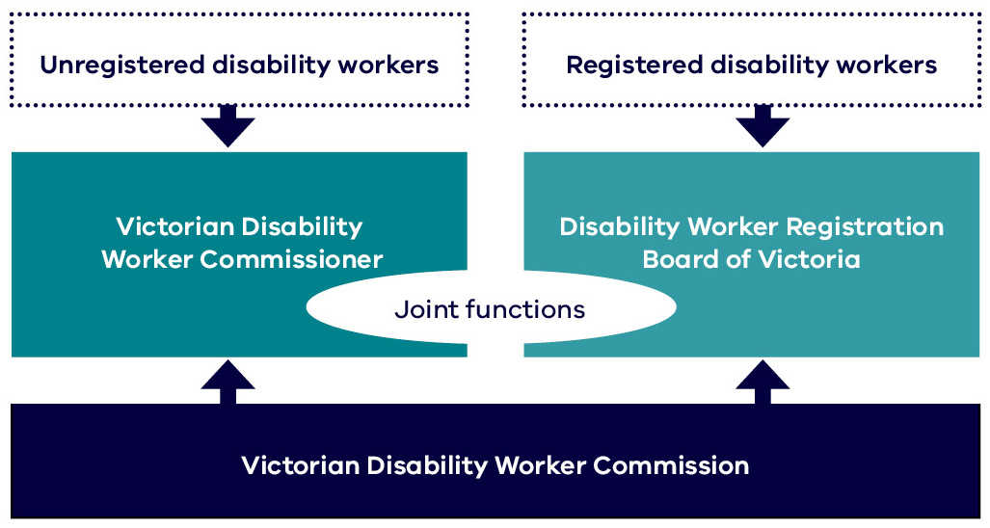

# What we regulate

Our role is to regulate disability workers providing services to people with disability in Victoria to – minimise harm; increase the quality of disability services provided by workers; and support service users to choose high quality, safe workers.

We achieve this by:

* regulating registered and unregistered disability workers
* offering and promoting a voluntary registration scheme for disability workers designed to lift work force standards and promote and recognise registered disability workers
* encouraging, assessing and managing complaints, referrals, and mandatory notifications about disability worker conduct
* monitoring and enforcing compliance with mandatory standards, registration and practice standards for workers
* maintaining and building relationships with co-regulators, regulatory partners and service users.

We define ‘compliance’ as adhering to legal requirements and obligations under the Acts, Regulations and Standards administered by us. Compliance is an ongoing process where workers and providers need to regularly assess their risk of non-compliance and seek to improve their methods and practices for eliminating or minimising those risks.

**‘Enforcement’** is the mechanism by which we respond to compliance issues and failures through influence (including education), authority, and use of our statutory powers.

# Who we regulate

We regulate disability workers who provide a disability service to a person with a disability in Victoria. We also regulate supervisors and managers of disability workers providing a service.

Disability workers provide a disability service to a person with disability so that they can undertake day to day activities such as communication, social or economic participation, social interaction, learning, mobility, self-care, and self-management.

Our dutyholders, that is the people who hold a duty to ensure that people with disability who use services enjoy human rights and the related duty to abide by the DSS Act, including the duty to abide by the code of conduct and make mandatory notifications include:

* disability workers – who provide services to a person with disability in Victoria regardless of how they are funded
* disability support staff or therapists – who support people with a disability in group homes or supported residential accommodation
* aged care workers – who care for people with disability, such as cognitive impairments at their home or in a residential facility
* workers who provide cooking and cleaning services – for a person with disability in their home
* managers and supervisors of service providers – who oversee, direct or are responsible for disability workers.

# Our co-regulators and partners

We work with a range of entities and partners that have complementary regulatory roles that intersect with the disability sector.

We actively work with co-regulators and partners at the state and federal levels in liaising and sharing information where appropriate and legally permissible. A list of our key co-regulators and partners and their roles is outlined on page 15.

# Our desired regulatory outcomes

We regulate all disability workers providing disability services in Victoria, regardless of how they are funded, to minimise harm to people receiving disability services, and deliver on our desired regulatory outcomes.

We are successful if:

* we reduce harm, abuse and neglect of people receiving a disability service from a disability worker
* we drive an increase in the quality of disability services provided by workers and
* people with a disability choose high quality, safe workers.

# Our harms of concern

People with a disability have a right to be free from harm and abuse. We seek to minimise harm and the risk of harm to people receiving disability services from a disability worker directly, and through our co-regulators and partners.

Harm has a broad definition within our regulatory scheme and includes physical, psychological, emotional, and financial harm as well as impacts on the rights and dignity of disability service recipients.

The harms we seek to prevent, minimise and where possible eliminate include:

|  |  |
| --- | --- |
| Harm | Description of harm |
| Distrust of disability workers | Arising from worker actions or perceived actions impacting trust of individuals and sector, or less use of disability services |
| Financial harm or exploitation | Including pressure for gifts, loss of spending autonomy, misuse of funds, fraud or theft |
| Restrictive practices | Unlawful use of physical, chemical, mechanical or environmental restrictive practices |
| Disempowerment | Denial or reduced participation, loss of control, isolation, inability/fear to complain or self-advocate, disrespect, or intimidation |
| Neglect | Including conscious (deliberate) and unconscious (negligent) dereliction of duty |
| Psychological and emotional abuse | Creating a feeling of harm, trauma, fear for personal safety, distress, loss of self-confidence or sense of self, loss of personal agency |
| Sexual harm and exploitation | Including unwanted comments, leering, grooming, exposure to pornography, contact or assault |
| Physical harm | Including that arising from injury, violence, fear, trauma, practices (such as restrictive practices), or environment |
| Avoidable death | Resulting from action or inaction by a disability worker |

# Our expectation of disability workers

In working with co-regulators, partners and disability workers we will seek to prevent, minimise, or avoid harms of concern and deliver on our desired regulatory outcomes.

We expect that disability workers comply with their obligations under the law, meet mandatory standards and engage in practices that seek to manage the risk of harm.

We understand that most disability workers want to provide quality services, comply with regulatory requirements and are seeking to improve their practices.

For those who fail to comply, we will respond and escalate our compliance and enforcement response.

# Our regulatory principles

In undertaking our role, we will use our influence and authority in line with our regulatory principles. We are committed to meeting these principles in all we do and acting in a manner that is both predictable and effective.

| Principle | Our commitments |
| --- | --- |
| **Collaborative** | * We will listen to and seek to understand the experience of people receiving a disability service and their families to improve outcomes * We will work with providers and disability workers to understand their obligations and provide safe and quality services * Where regulatory regimes complement and intersect, we will work with co-regulators to share information, target regulatory effort and achieve quality and safety |
| **Effective** | * We will analyse information to identify risks and allocate resources where they have the greatest positive effect to protect the safety, wellbeing and rights of people with disability accessing services * We will seek to remedy harm and use every interaction to increase the quality of disability services provided by workers * We will leverage our sanctions to encourage compliance |
| **Accountable** | * We will be objective, timely and open in our decision making, explain our reasons and what we expect * We will report on our performance to enable continuous improvement * We will share information about our processes, respond promptly to complaints about our service co-operate fully with all external scrutiny mechanisms |
| **Fair** | * We will take regulatory action that is proportionate to the problem we seek to address, and considers the behaviour and response of the disability worker and service recipient * We will be consistent and predictable in driving outcomes from our actions |
| **Inclusive** | * We will put people with disability at the centre of our work and recognise different types of disadvantage * We will be informed by engagement with people with disability, carers, disability workers and disability organisations |

# Our regulatory approach

Our regulatory approach is the way we use our collective authority and influence to shift behaviour of our dutyholders to minimise harms of concern and deliver on our desired regulatory outcomes. We apply a combination of methods based on the willingness, ability, behaviour, and capacity of disability workers. Our approach includes:

| Approach | Method |
| --- | --- |
| Raise awareness and educate | * We communicate our role to disability workers in Victoria to ensure safer services and better choices for people with disability * We regulate all disability workers through a mandatory code of conduct and a voluntary registration scheme designed to lift work force standards and promote and recognise disability workers * We promote and build demand for registered disability workers while ensuring acceptable standards of conduct are maintained * We educate service users about their rights and promote an accessible system to submit complaints about disability worker conduct |
| Set standards for disability workers and students | * We set requirements for all disability workers through mandatory codes of conduct * We set standards to qualify for and maintain voluntary registration including required skills, experience and continuing professional development * Over time, we plan to promote quality workforce standards through requirements for training programs, competencies and maintaining continuing professional development |
| Encourage voluntary registration | * We approve and build demand for registered disability workers who meet our standards * We promote high quality people-centerer disability workers by requiring registered disability workers to complete continuing professional development each year * We grant or refuse applications for registration for disability workers, and publish and promote those disability workers who have met our standards |
| Support to comply | * To maximise voluntary compliance – we provide practical and constructive support on mandatory and voluntary standards and identifying and managing risks for people receiving disability services * Responsibility for compliance rests with disability workers, and we assume most want to do the right thing as part of a growing professional workforce |
| Monitor compliance and complaints | **Reactively**   * We encourage, receive and assess complaints, referrals, and notifications about disability workers * We analyse complaints and notification trends to support proactive and preventative activity and inform policy makers and the Minister where regulatory changes are needed   **Proactively**   * We look for opportunities to use intelligence and partnerships to monitor compliance with: * mandatory standards captured in the code of conduct, * registration and practice standards, and advertising of services provided by registered workers |

We assess, review and investigate non-compliance and undertake a range of actions –

| Refer | Remedy | Sanction |
| --- | --- | --- |
| We may inform or work with another regulator where they are better placed to regulate or minimise the harm – by   * referring complaints, notifications and matters * notifying of decisions we’ve made * providing information, evidence or intelligence * linking impacted parties with a co-regulator | To stop non-compliant activity, prevent further harm (including during investigations), and make good we may –   * conciliate complaints * counsel workers * get remedy by agreement or by accepting an undertaking * caution or show cause * issue an interim prohibition order * impose a condition on registration * suspend a registration* | To penalise, punish or deter non-compliant activity we may –   * refer a matter to a Health or Professional standards panel * refer a matter to VCAT where the Board believes a disability worker has engaged in professional misconduct; their registration was improperly obtained or it is required by a panel * issue a prohibition order * disqualify a person from applying for registration* * revoke a registration* * seek a fine* |

*Remedy or Sanction occurs through application to VCAT

Figure 2: Our regulatory approach

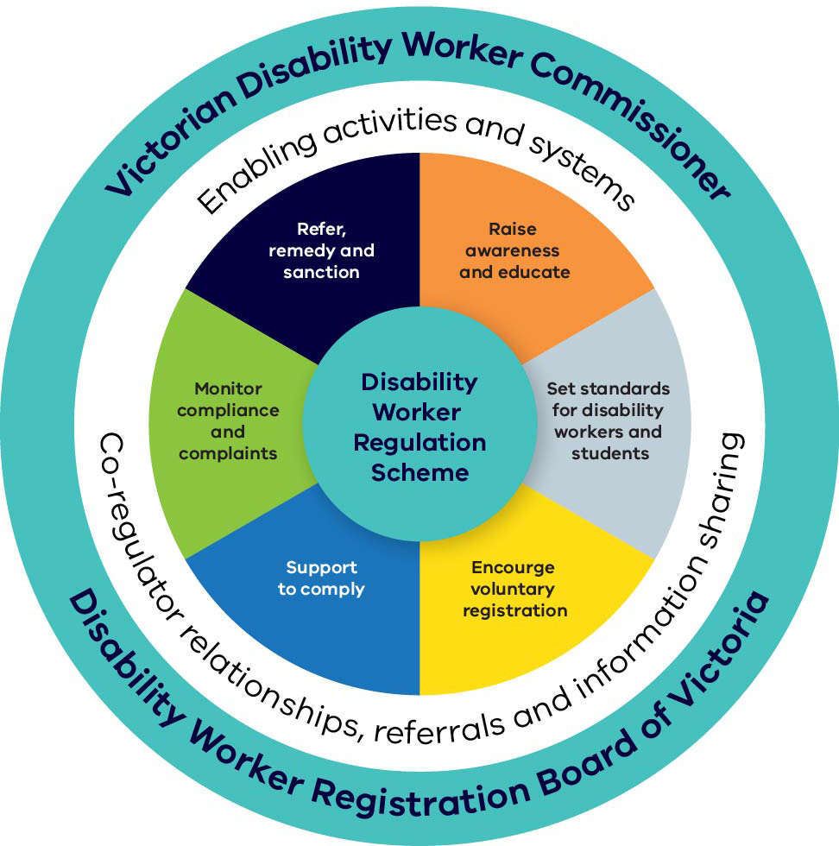

# Our risk-based approach

## How we prioritise and allocate regulatory effort – our risk-based approach

We prioritise our regulatory effort according to an assessment of harms, and risks of harm, to people with a disability receiving services from a disability worker.

Our risk-based approach prioritise key activities including:

* **monitoring of compliance and complaints** (such as assessments, reviews and investigations)
* **awareness raising** (for example, campaigns, education resources or compliance guidance)
* **enforcement** (for example through referrals, remedial action or sanctions).

All disability workers are subject to compliance or complaint monitoring directly by us or through co-regulator relationships, referrals or information sharing.

We consider risk and intelligence, such as complaints, field insights, notifications and referrals, in deciding the level, frequency and focus of any monitoring activities.

We monitor data and intelligence from co-regulators and partners to assess the likelihood of risks occurring and their impact, and determine effective and proportionate allocation of regulatory resources.

We assess and prioritise risk based on the:

* **consequence of non-compliance** – the severity of potential or actual impact of harm on people with disability receiving a disability service (see table 1)
* **likelihood of non-compliance** – how likely it is that a disability worker will not meet their obligations, based on their compliance history, ability to identify and manage risk, and their or a providers compliance attitude (see table 2).

**Assessing consequence** – Table 1 provides a guide on the scale of harms or consequences we consider when prioritising effort. Where disability workers and providers are responsible for preventing or managing serious harms, we consider potential consequences of those harms when allocating or directing effort.

For example – while the likelihood of non-compliance may be low, if the consequences of non-compliance are severe, more regulatory effort will be directed to ensure risks are well managed.

Figure 3: Our model for risk-based prioritisation

A square graph showing progressive consequence and likelihood with low risk and rare in the bottom left corner to severe and certain in top right corner.

Table 1: Scale of consequences of non-compliance

|  |  |
| --- | --- |
| Scale | Description of consequence |
| Severe | * Avoidable death * Severe, permanent, or life-changing injury |
| Major | * Premature expected death * Substantial or long-lasting physical or psychological injury * Significant financial harm or life impacting loss of funds |
| Moderate | * Exacerbate existing illness or development of injury requiring regular treatment * Distrust of disability workers impacting service access * Financial harm with short-term impact on quality of life * Developmental issues |
| Minor | * Temporary impairment with short-term recovery * Diminishment of rights or temporary loss of control |
| Low | * Minor injury * Short term disrespect; loss of agency; restrict food, activity or choice |

**Assessing likelihood** – outlines the factors that we consider when assessing the likelihood of non-compliance and building basic risk profiles of disability workers and providers.

Workers and providers who manage their risks well, have applied for and been granted voluntary registration or have higher levels of training are more likely to comply. Therefore they are likely to be considered to require less oversight and be subject to less compliance monitoring.

For example – those providers or workers with a poor compliance history, and who are, or employ, workers who are not part of the voluntary registration scheme, are more likely to be subject to more regulatory attention.

Table 2: Factors we consider to determine the likelihood of non-compliance of workers or providers

|  |  |
| --- | --- |
| Scale | Factor |
| Certain | * Refusal to comply, provide information or cooperate * Misrepresent worker qualifications, capability, or capacity impairment * Significant substantiated or outstanding complaints * Not meeting or repeated failure to meet acceptable standards or understand participant needs |
| Likely | * Pattern of repeated non-compliance or disciplinary history * High volume of complaints including complaints or notifications from co-regulators * Task or services require higher level of skills or knowledge than worker capability |
| Possible | * Numerous previous non-compliance or substantiated complaints * Tasks or services being performed without adequate skills or knowledge * Poor risk identification, management and practices by provider or worker * Potential for outdated methods or practices requiring knowledge update |
| Unlikely | * Previous isolated ‘one-off’ non-compliances or complaints * Awareness of risks and needs reflected in provider’s systems of work, or worker practices |
| Rare | * No previous non-compliance recorded or concerns about capability * No complaints * Service provider has good systems of management, risk identification and practices * Worker known as a good performer or has a cooperative attitude |

# Our regulatory toolkit

We prioritise our regulatory effort by assessing harms, and risks of harm, to people with disability receiving a service from a disability worker.

Our legislative and policy frameworks provide us with a range of regulatory tools to maintain and ensure compliance, and where necessary take enforcement action directly, or through a tribunal (such as VCAT) or court.

We minimise harm and deliver on our desired regulatory outcomes through applying our regulatory approach and a combination of our regulatory tools and voluntary registration scheme.

In all cases, we will seek to prevent non-compliance through education, support, and encouragement to comply as an initial starting point. We will utilise a range of regulatory tools where necessary to secure compliance.

Our tools, outlined in our regulatory approach, are grouped into several areas:

| Tool | Role |
| --- | --- |
| **Voluntary registration** | Where we assess applications for registration from disability workers to determine if they qualify and are suitable to hold registration against acceptable standards and, where successful, include them in a public register  of disability workers.  Preventative risk management, by identifying and screening applicants to ensure mandatory and acceptable standards, suitability, skills and competency requirements are met. Addressing potential shortcomings and imposing interim or on-going operational requirements, conditions, or limitations on registration to minimise risk, harm, and non-compliance.  Where successful, applicants are included in a public register of registered disability workers.  *Examples include the ability to refuse to issue a registration, or make it subject conditions.* |
| **Compliance guidelines** | Publishing guidance in relation to mandatory standards or registration requirements that disability workers must meet or comply with.  *Examples include guidance on registration requirements set by the Board.* |
| **Education** | Provision of information  *Examples include proactive provision of information on our website such as through fact sheets or reactively in response to a complaint or notification.* |
| **Information gathering and compliance monitoring** | Proactive and responsive measures to monitor performance, detect non-compliance, identify risks, compel information or identify compliance guidance needs.  *Examples include ability to investigate, review or assess a disability worker’s conduct proactively or in response to a complaint, referral, or notification.* |
| **Notifiable conduct** | Requires mandatory notification to the Commissioner by a disability worker or service provider where they reasonably believe another worker has engaged in unacceptable conduct.  *Examples includes where a disability worker notifies the Commission where they form a reasonable belief that another disability worker has behaved in a way that constitutes notifiable conduct.* |
| **Remedial** | Where we will act to stop non-compliant activity, prevent further harm, minimise harm during an active investigation or require a disability worker to make good.  This often requires a disability worker to fix identified non-compliance to ensure a problem is rectified or non-compliance prevented.  *Examples of remedial action include where we may:*   * *conciliate complaints and counsel workers ranging from educative to cautionary* * *get remedy by agreement or by accepting an undertaking* * *issue an interim prohibition order* * *impose a condition on registration, or seek to suspend registration* |
| **Referral** | Sharing information, joint operations and referrals that allow better targeting and intervention of the disability worker or provider by co-regulators. Such as, the NDIS Quality and Safeguards Commission, Human Services Regulator, or system owners or funders in another part of government |
| **Sanctions** | Where we will act, directly or through a tribunal or court, to penalise or punish a disability worker or to deter non-compliant activity more generally.  This may be done to prevent disability workers from committing further compliance breaches and placing people at serious risk and/or to promote compliance through deterrence.  *Examples include prohibition orders, infringements, suspension/cancellation of registration, court action* |

# Our enforcement approach

Our objective is always to detect and seek remedy of non-compliance to minimise harm and deliver on our desired regulatory outcomes.

We will prioritise the non-compliance being rectified to prevent the harm from re-occurring. We will do this through education, seeking voluntary remedial action, by directing it through placing conditions on registration, accepting an undertaking, prohibiting or limiting activity of a disability worker until the issue is resolved.

Where we identify non-compliance, our regulatory response will depend on an assessment of:

* **Risk or harm from non-compliance** – considering the likelihood and consequences of non-compliance (i.e., the harm or likely harm); and
* **Attitude to compliance and culpability** – considering the degree of fault in the non-compliance related to disability worker or service provider behaviours and attitude, and what steps they could or should have taken to avoid non-compliance i.e., their responsibility in relation to the non-compliance.

For example, if the disability worker or service provider knew of serious risk but did not take any reasonable steps to mitigate it, or a provider failed to appropriately allocate a sufficiently able disability worker based on the known needs of a service recipient, we consider the level of accountability to be higher and they are more likely to receive a stronger response.

The following table outlines some of the factors we consider when evaluating a disability worker or provider’s attitude to compliance and their culpability at the time or post conduct.

|  |  |
| --- | --- |
| Scale | Factor |
| Severe | * Deliberate, wilful or misleading conduct, omission, or criminal action * Repeated non-compliance and past convictions, bans or code violations * Non-compliance involved significant falling short of accepted standards |
| Major | * Acted recklessly giving no thought to risk despite obvious consequences * Non-acknowledgement, non-engagement, or significantly delayed regulatory processes * No remedial action or effort to understand or resolve compliance issues * Foreseeable and easily preventable – serious concerns of participant, carer or family ignored |
| Moderate | * Knowing and aware of ‘wrongdoing’ but lax attitude/indifference requiring regulatory intervention * Lack of insight into wrongdoing and consequences * Risk, or impact of any impairment, foreseeable and preventable * Pattern of disregard towards compliance and failure to address reoccurrence of non-compliance |
| Minor | * Didn’t anticipate or intend harm with insight and understanding into impacts of behaviour * Understanding that the circumstances that led to misconduct and why it was below acceptable standards * Proactively engages with regulatory processes * Action taken to prevent non-compliance re-occurring or improve capability |
| Low | * No history of non-compliance * Remedial action taken to prevent re-occurrence or future harm * High level of interest, insight or engagement to improve practice |

Figure 4: Enforcement pyramid – illustration of our enforcement approach and how harm,   
the consequence of non-compliance, compliance attitude and culpability is considered.

We will publish and publicise enforcement outcomes that are in the public interest to inform the community of our regulatory actions, increase deterrence and encourage on-going compliance.

A pyramid diagram depicting the enforcement approach. The left-hand side of the pyramid depicts the levels of compliance attitudes to worker culpability, from ‘Try and mostly succeed’ at the bottom, ‘Try to but don’t always succeed’, ‘Unwilling to comply’ and ‘Have decided not to comply’ at the top. The right-hand side of the pyramid depicts the levels of risk or harm from non-compliance. The pyramid itself is made up of the different enforcement actions. The levels from bottom to top are: Education, advice, engagement and guidance; counsel worker, concilia-tion, warning, remedial agreement, notification to co-regulator; show cause with conditions, investigation, registration amendment, undertaking, referral to co-regulator; major investiga-tion, suspend registration, interim prohibition order; prohibition order, revoke registration, seek infringement; court action

# Reviews and appeals of regulatory decisions

We will conduct ourselves in an open and transparent manner, explain our decisions, be open to scrutiny and review, and show integrity in our efforts to learn from our mistakes and continually improve our performance.

We hold ourselves accountable as we hold others to account. Avenues to review our regulatory decisions and conduct are identified in the following sections.

## Avenues for review of our regulatory decisions

Where a registered disability worker or disability student is not satisfied with a decision relating to registration, they may seek to have our decision reviewed. In the case of changing or removing conditions or changing or revoking an undertaking, applications for review can be made to the Board.

In some instances, legislation provides for a review of our registration decisions at the Victorian Civil and Administrative Tribunal (VCAT). For example, VCAT can review a decision to refuse to register, renew or to change the type of registration of a disability worker.

VCAT can also review some of our enforcement actions. For example, a disability worker can apply to VCAT for review of a decision to issue an interim prohibition order or issue a prohibition order.

A detailed list of reviewable decisions is provided in section 215 of the Disability Service Safeguards Act. We do not provide legal advice to dutyholders – they should always seek their own legal advice regarding their ability to have a decision reviewed or appealed.

## Opportunities for internal review

Where a disability worker is unhappy with an enforcement action taken against them – and it is not a reviewable decision under section 215 of the Disability Service Safeguards Act – we may provide an opportunity to have the decision reviewed internally by someone who did not make the original decision.

The disability worker can apply for an internal review of an action taken against them by writing to us within 14 days of the original decision and outlining what decision they were expecting, why they think we should make a different decision and providing any information they would like us to consider. If we accept the review, we will aim to resolve it within 60 days.

## Our accountability

We welcome scrutiny of our services and expect all Commission staff to act professionally and with integrity. If a disability worker or any other person has a concern about our services or the conduct of our staff, we invite them to contact us. Our complaints and feedback policy is available [here](https://www.vdwc.vic.gov.au/sites/default/files/2020-08/VDWC%20-%20Complaints%20and%20feedback%20policy%20-%20August%202020.pdf). If there is a complaint we cannot resolve, we will refer people to the appropriate external scrutiny body. In most cases this will be the Victorian Ombudsman.

For example, our authorised officers and investigators have a range of powers to make enquiries, ask questions, examine, and take copies of documents, and in some cases obtain search warrants to enter sites and seize evidence.

We expect our officers to act professionally and with integrity when engaging with dutyholders and stakeholders. Where officer conduct is regarded as inappropriate, constitutes a believed misuse of statutory power, is discriminatory or reflects badly on the Commission or the Registration Board, we invite concerned parties to complain to us.

# List of co-regulators and partners

We work with a range of co-regulators and partners that have regulatory oversight or responsibilities that intersect and complement our role in regulating disability workers. A list of our key co-regulators and partners and their roles is outlined in the table below.

| Who | Role | Abbreviation |
| --- | --- | --- |
| Australian Health Practitioner Regulation Agency | Regulates Australia’s health practitioners in partnership with National Boards and implements the National Registration and Accreditation Scheme across Australia | **Ahpra** |
| Commission for Children and Young People | Promotes improvement in policies and practices that affect the safety and wellbeing of Victorian children and young people | **CCYP** |
| Commissioner for Seniors | Provides independent advice and advocacy to the Victorian Government on issues relevant to senior Victorians | **CFS** |
| Disability Services Commissioner | Helps resolve complaints raised by, or on behalf of people who receive Victorian disability services | **DSC** |
| Health Complaints Commission | Resolves complaints about healthcare and the handling of health information in Victoria – Investigates and reviews complaints data to help service providers improve service quality | **HCC** |
| Human Services Regulator (Social Services Regulator) | Regulates human services to minimise harm and to protect the safety and rights of children, young people and adults who receive human services that are funded or regulated by DFFH | **HSR (SSR)** |
| Mental Health and Wellbeing Commission  (Planned 2023) | Will hold government to account for the performance, quality and safety of Victoria’s mental health and wellbeing system | **MHWC** |
| Mental Health Complaints Commissioner | Safeguard rights, resolves complaints and recommends improvements to public mental health services | **MHCC** |
| NDIS Quality and Safeguards Commission | Works with participants and providers to improve the quality and safety of NDIS services and supports | **NDISC** |
| Office of the Public Advocate | Human rights organisation which promotes the diversity and inclusion of all people - hosts Community Visitors (CVs) who visit accommodation facilities for people with disability or mental illness | **OPA** |
| Professional Bodies | Regulate professional and ethical obligations of members (e.g., Association of Social Workers, Nurses, Psychologists, Health care workers) | **PCB** |
| Transport Accident Commission | Pays for treatment and benefits for people injured in transport accidents and promotes road safety | **TAC** |
| Victoria Police | Serve the community and uphold the law to promote a safe, secure, and orderly society | **VicPol** |
| Victorian Equal Opportunity and Human Rights Commission | Protect human rights, promote fair treatment for all Victorians, and advocate for a diverse and inclusive state | **VEOHRC** |
| Victorian Institute of Teaching | Recognises and regulates members of the teaching profession in Victoria | **VIT** |
| Working with Children Check | Screening process for assessing or re-assessing people who work with or care for children in Victoria | **WWCC** |
| WorkSafe Victoria | Workplace health and safety regulator focused on reducing workplace harm and improving outcomes for injured workers | **WSV** |

# Transparency

This document is publicly available and can be provided to any person upon request.

|  |
| --- |
| To receive this publication in an accessible format phone 1800 497 132, using the National Relay Service 13 36 77 if required, or email the Victorian Disability Worker Commission  <info@vdwc.vic.gov.au>.  Authorised and published by the Victorian Government, 1 Treasury Place, Melbourne.  © State of Victoria, Australia, (Victorian Disability Worker Commission and Disability Worker Registration Board of Victoria) 2023.  This work, Disability Worker Regulation Scheme Regulatory Approach, is licensed under a Creative Commons Attribution 4.0 licence <creativecommons.org/licenses/by/4.0/>. You are free to reuse the work under that licence, on the condition that you credit the author, indicate if changes were made and comply with the other licence terms.  ISBN 978-1-76130-134-6 (pdf/online/MS word)  Available at the [Victorian Disability Worker Commission’s website](http://vdwc.vic.gov.au/) <vdwc.vic.gov.au>. |