Victorian Disability Worker Commission and Disability Worker Registration Board of Victoria
Corporate plan 2022–24
Update April 2024

Acknowledgement of Country
We proudly acknowledge Victoria’s First Nations peoples and their ongoing strength in practising the world’s oldest living culture. We acknowledge the Traditional Owners of the lands and waters on which we live and work and pay our respect to their Elders past and present. We acknowledge the ongoing role of the Aboriginal community in supporting those with disability.

Accessibility statement
The Victorian Disability Worker Commission aims to make its information and publications accessible to all. This corporate plan has been designed in both a PDF and accessible
Word format. If you require an alternative format, please email the Commission <info@vdwc.vic.gov.au>.
The Commission and Board are statutory entities of the State Government of Victoria created under the Disability Service Safeguards Act 2018.
© State of Victoria (Victorian Disability Worker Commission and Disability Worker Registration Board of Victoria) 2022
The Victorian Disability Worker Commission and Disability Worker Registration Board of Victoria corporate plan 2022–24, updated April 2024, is licensed under a Creative Commons Attribution 4.0 licence.
You are free to re-use the work under that licence, on the condition that you credit the State of Victoria (Victorian Disability Worker Commission and Disability Worker Registration Board of Victoria) as author, indicate if changes were made and comply with other licence terms. The licence does not apply to any images, photographs or branding, including the Victorian Government logo, Victorian Disability Worker Commission logo, the Disability Worker Registration Board of Victoria logo and the logos used to certify registration as a registered disability worker.
Copyright queries may be directed to <info@vdwc.vic.gov.au>
ISSN 2653-6161 – Online (pdf/word) format
Published April 2024
Victorian Disability Worker Commission
Level 20, 570 Bourke Street
Melbourne Victoria 3000
Phone: 1800 497 13

Contents
Message from Commissioner and Board Chairperson 4
About us 5
Our purpose 5
What we currently do 5
Our regulatory approach 5
Our operating environment 7
Our values 9
Diversity and inclusion 9
Independent and fair 9
Fearless and accountable 9
Trust and respect 9
Empathy and dignity 9
Our Scheme strategic plan 2022–24 9
About the Corporate Plan 2022–24 9
Our maturity model 10
Our focus for 2023–24 13
Tracking our performance 16
Monthly review of key performance indicators and measures 16
Performance reporting against our business plan 16
Statement of expectations 16
Approach to risk management 17

Message from Commissioner and Board Chairperson
We are pleased to present this corporate plan, which sets out how the Commission will implement the Board and Commission’s joint strategic plan in 2023–24. This corporate plan builds on the foundations of the first three years of building and implementing the Disability Worker Regulation Scheme.
In this fourth year of delivering regulatory operations for the Commission and third year of registration for the Board, we are pleased to be driving a number of areas of important work to ensure the long-term sustainability of the Scheme. We are nevertheless also aware of many of the challenges ahead of us as we work to achieve our strategic outcomes.
Whilst we continue the essential parts of our work of taking complaints, receiving notifications and registering disability workers and practitioners, this plan highlights the key actions to achieve our priorities over the next year. In line with the stage of development of the Board and Commission, our strategic activities are focused on engaging with the disability community, ensuring stakeholders come to us with complaints and notifications, promotion of high standards for workers and developing our capacity to achieve a high quality and safe disability workforce in Victoria.
In particular we are looking at engaging with the disability community to: (1) further increase the number of complaints and notifications regarding unsafe or poor-quality disability services; and (2) grow the number of disability worker registrations in key parts of the sector. In identifying our key strategic actions and projects for the next financial year we have given urgency to those that have the biggest impact for our organisation as well as benefits to our stakeholders.
We are aware of the difficulties that the shortage of workers has had on our sector and its range of implications. We are committed to work closely with our stakeholders in the implementation of the scheme so that together we can attract high-quality workers to the sector and make a real difference to people living with disability.
The corporate plan does not provide detail on the 2024–25 actions as the Commission has only received budget allocation until June 2024. We have limited our annual planning to known resources whilst we operate on the basis that for the following year we will receive a similar budget to this year, plus funding for some specific areas of work. In a way it is an ambitious corporate plan; however, it is one we believe we can achieve.
Dan Stubbs
Commissioner
Victorian Disability Worker Commission
Melanie Eagle
Chairperson
Disability Worker Registration Board of Victoria

About us

Our purpose
We regulate all workers providing disability services in Victoria, regardless of how they’re funded, setting standards for registration and training, resolving complaints and prohibiting unsafe workers.

What we currently do
This is the shared corporate plan for the Victorian Disability Worker Commission (Commission) and the Disability Worker Registration Board of Victoria (Board).
We manage the Disability Worker Regulation Scheme by:
- regulating registered disability workers through a voluntary registration scheme
- developing professional registration standards to promote professionalisation of the disability workforce
- regulating the conduct of all disability workers operating in Victoria via a Code of Conduct
- investigating and responding to complaints and notifications about disability workers
- sharing appropriate information with regulators about disability workers to support quality and safety in the disability workforce.
For a full list of Board and the Commission functions please see the Disability Service Safeguards Act 2018.
Figure 1 illustrates the interrelationships between the roles of the Commission, the Commissioner and the Board.
Figure 1: Interrelationships between the Commission, the Commissioner and the Board
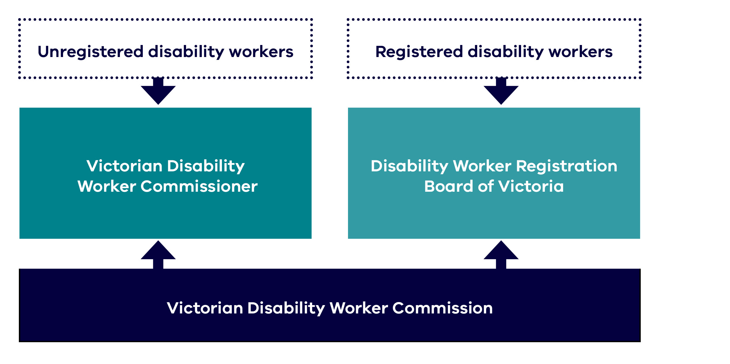

Our regulatory approach
Our regulatory approach describes the work that we undertake, how we make our decisions and the types of actions that we can undertake to support our vision for people with disability to be able to choose services that best meets their needs and supports their quality of life free from abuse and neglect. The Commission and Board published their regulatory approach on the website on 22 May 2023.
We regulate disability workers who provide a disability service to a person with a disability in Victoria. We also regulate supervisors and managers of disability workers providing a service.
In working with stakeholders, we will seek to prevent, minimise, or avoid harms of concern and deliver on our desired regulatory outcomes. We use a number of tools in support of this approach including:
- raising awareness and educating
- setting standards for disability workers
- encouraging voluntary registration
- supporting compliance with the Code of Conduct and standards
- monitoring compliance and complaints.
Our regulatory principles are: collaborative, effective, accountable, fair and inclusive.
Figure 2: Our regulatory approach
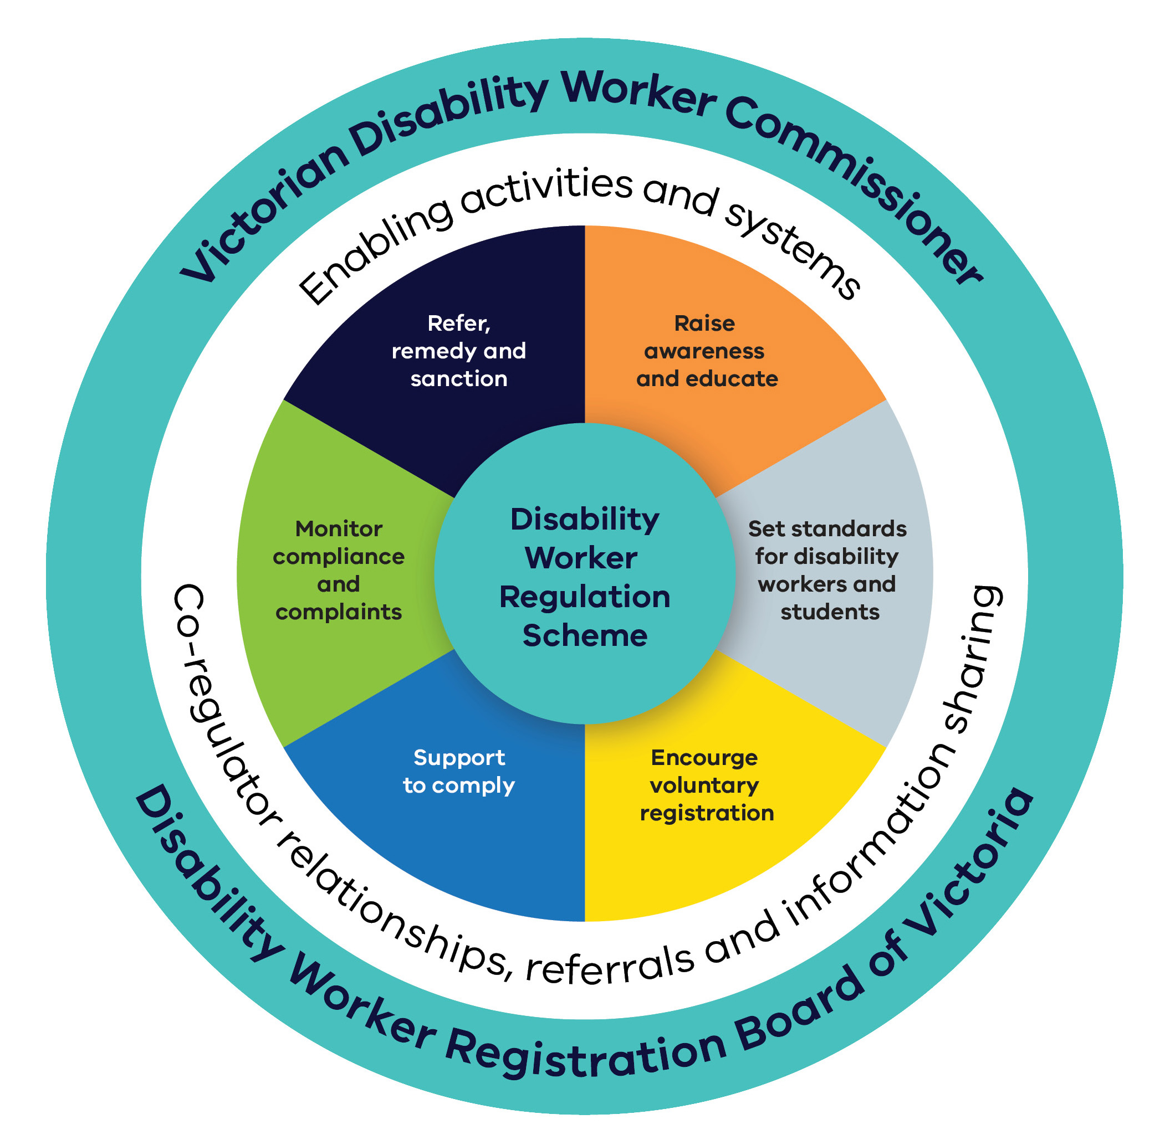

Our operating environment
In Victoria, 17 per cent of people identify as having a disability. Thirty-two per cent of people with disability sometimes or always need help with self-care, mobility or communication.
In Victoria, just over 10 per cent of the 1.1 million Victorians with disability are eligible for a National Disability Insurance Scheme (NDIS) plan. This means that many Victorians receive support outside the NDIS framework.
The Scheme covers both NDIS and non-NDIS disability workers and protects people with disability, including those who are not NDIS participants. This represents the majority of Victorians with disability who use support services.
In Victoria, many bodies work together to support safe disability services. We work with other agencies and organisations, as well as other workforce regulators including:
- Australian Health Practitioner Regulation Agency
- Commission for Children and Young People
- Commissioner for Seniors
- Disability Services Commissioner
- Health Complaints Commission
- Human Services Regulator (Social Services Regulator)
- Mental Health and Wellbeing Commission (Planned 2023)
- Mental Health Complaints Commissioner
- NDIS Quality and Safeguards Commission
- Office of the Public Advocate
- Professional Bodies
- Transport Accident Commission
- Victoria Police
- Victorian Equal Opportunity and Human Rights Commission
- Victorian Institute of Teaching
- NDIS Worker Screening Unit and Working with Children Check Victoria (Department of Government Services)
- WorkSafe Victoria.
In Victoria, we also work closely with the Department of Families, Fairness and Housing.
Disability support work is complex. It needs a workforce with the skills and expertise to provide safe, quality supports.
More broadly, there are pressures on the supply of the workforce in the disability sector. Key factors impacting the size of the workforce include:
- competition for workers with other sectors including aged care and childcare
- casualisation of the workforce, which is female dominated
- relatively low pay rates.
A high turnover rate amongst casual disability workers has also added pressure to the disability workforce. The turnover rate has increased from 18 per cent in December 2020 to 22 per cent in June 2021.
The past 12 months has also seen the return to pre-COVID work practices that has enabled the Commission to build on opportunities to engage with people with disability and the disability workforce, including by more face-to-face engagement with stakeholders. This is one area that will be prioritised going forward as implementation of the Scheme continues.
The Commission and Board are committed to increasing awareness and understanding of the Scheme. Consultation on all aspects of the Scheme including registration standards is vital to ensure that registered disability workers possess attributes that are important to people accessing disability services.
The Commission and Board continue to engage with and listen to the perspectives of people with disability to ensure the Scheme is implemented in a person-centred way.

Our values
Our values inform what we do and how we do it.

Diversity and inclusion
- We have inclusive recruitment and employment practices that foster diversity in our workforce
- We ensure that diverse communities see themselves reflected in who we are and
what we do
- We are committed to being an accessible workplace and an accessible regulator for our diverse stakeholders

Independent and fair
- We treat everyone with respect, listening to all parties involved
- We do what we say we will do and we take proportionate action
- The community sees our processes and the decisions we make as independent and transparent

Fearless and accountable
- We use our powers to hold others accountable for their actions
- We are responsible for our actions and are open to scrutiny and feedback
- We continually evaluate and improve our operations

Trust and respect
- We are respectful and professional in our interactions with our colleagues and the community
- We foster trust by assessing matters impartially
- We have confidence in, and are respectful of, each other’s skills and capabilities

Empathy and dignity
- We take a person-centred approach with everything we do
- We ask people what they need from us and how we can work with them
- We are responsive and flexible to support the diverse communities and individuals we serve

Our Scheme strategic plan 2022–24

About the Corporate Plan 2022–24
This two-year corporate plan is designed to be updated once, at the end of the 2022–23 financial year, with all the relevant information for the 2023–24 financial year. A new three-year strategic plan will be launched in 2024 to replace this corporate plan.

Our maturity model
As a new organisation we have to be conscious that our journey recently began, and that maturation requires time and effort. With this in mind we have designed an ambitious four-phase model to ensure that by 2024 we can operate at the same level of any established organisation.

2020–22 Phase 1: Foundational
The focus of this first phase is to prepare and develop foundational pieces that allow for initial operation.

2022–23 Phase 2: Establishment
At this phase, the focus is to engage with our external stakeholders to collect evidence to improve our operations.

2023–24 Phase 3: Consolidation
The focus of this phase is to consolidate our way of operating and assess how far we have come in implementing the Scheme.

2024–onwards Phase 4: Continuous improvement
At this phase, our operating model has been consolidated and ongoing changes are made based on key performance indicators.

Scheme strategic plan 2022–24
The plan has five pillars in total, the first four representing where the Scheme needs to concentrate its efforts to support people with disability, and a fifth pillar describing the crucial support required to enable the functions and delivery of pillars 1–4 acknowledging the relationships between the Commissioner, the Board and the Commission.

Figure 3: Strategic Plan 2022–24 on a page
The Victorian Disability Worker Regulation Scheme Strategic Plan 2022/23–2023/24
Vision | People with disability can choose services that best meet their needs and supports their quality of life, free from abuse and neglect
Purpose | We regulate all workers providing disability services in Victoria, regardless of how they are funded, setting standards for registration and training, resolving complaints and prohibiting unsafe workers
Guiding Principle | People with disability who use disability services have the same rights as other members of the community
Pillars | I. Safety and  compliance | 2. Registration | 3. Workforce  standards | 4. Engagement and  communications | 5. Enablers
By mid 2024 | We have an accessible responsive and balanced notifications, complaints and assessment system | The percentage of the disability workforce that is registered is growing steadily | Our standards for registration and training improve the knowledge and capability of the workforce | People with disability, their families, advocates and service providers understand and have confidence in the Scheme and its processes | The Board, Commissioner and Commission work collaboratively and are well supported to develop and operate the Scheme
2022–24 priorities | 1.1 Develop and implement a compliance framework for the conduct of registered and unregistered workers  1.2 Establish and implement procedures for receiving, assessing and actioning notifications and complaints  1.3 Implement monitoring, evaluation and continuous improvement processes in relation to complaints and notification  1.4 Raise awareness of the Scheme’s complaints and notifications process | 2.1 Build knowledge of the benefits of registration for disability support workers, their employers, and for people with disability, their families, carers and advocates  2.2 Ensure the registration process is simple quick and easy to use  2.3 Promote registration to disability support workers  2.4 Build demand for registered disability support workers from:  - people with disability, their families, carers and advocates  - service providers | 3.1 Develop a roadmap to guide the development of guidelines, standards and accreditation  3.2 Prioritise standards for registration of disability support workers  3.3 Collaborate with organisations including employers who develop the workforce through curricula, qualifications and training  3.4 Strengthen the Commissions capability, capacity and resources to develop standards | 4.1 Work with other regulators and agencies in Victoria and nationally to:  - achieve quality and safety outcomes for people with disability  - avoid unnecessary duplication of effort  4.2 Build awareness of the role of the Board and Commission  4.3 Further strengthen our relationships with the community, sector and our stakeholders  4.4 Build our capability to engage and consult | 5.1 The Board, Commissioner and Commission have:  a) shared values and principles  b) a complementary partnership, underpinned by a respectful empowering and learning culture  c) high performing teams that draw on each other’s strengths  d) the necessary resources, capacity and capability  e) supporting technology hardware systems and applications  5.2 The Board, Commissioner and Commission collaboratively develop a regulatory approach that, is evidence-informed, risk-based, responsive and balanced  5.3 Progressively build an evidence-based understanding of the Scheme’s impact, strengths and shortcomings, and ways these may be addressed

Our focus for 2023–24
A significant proportion of our resources dedicated to delivering the Scheme are allocated to core regulatory and enabling functions (Table 1) and much of these, at this stage in our maturity journey, correspond to our consolidation phase.
At this stage in our maturity journey, we are moving to a phase that sees us consolidating our way of operating and assessing how far we have come in implementing the scheme. Our key priorities for this financial year are therefore to respond efficiently to the growing number of complaints and notifications regarding unsafe or poor-quality disability services. This reflects the maturity of the Scheme and the increasing number of people who use disability services and the number of complaints and notifications lodged with us.
Table 2 shows our key strategic projects for 2023-24. To this end we are consolidating our capabilities, profile and recognition in the disability sector. Much of our actions and deliverables this year are therefore also relate to expanding and deepening recognition and understanding of our work in the community. This important work will help us to build community confidence in the work of the Commission and Board.
The Board and Commission also plan to undertake analysis and consultation to prepare for the development and implementation of new important standards to promote the quality and recognition of disability workers registered under the Scheme.
Table 1: Core regulatory and enabling functions

Safety and compliance
- Complaint handling and responses
- Investigations
- Prohibition orders
- Working with other regulators

Registration
- Registration assessment
- Continuous improvement to application and renewal processes
- Customer support
- Publishing the register of registered disability workers

Workforce standards
- Policy directions and guidance
- Standards, guidelines development and fees
- Accreditation processes

Engagement and communication
- Stakeholder engagement
- Public information and education campaigns
- Media presence

Enablers
- Corporate compliance
- Internal audit
- Board Secretariat
- Strategic and operational policy
- Recruitment management
- Health and safety
- Finance
- Diversity and inclusion Legal advice
- Strategic planning and risk management
- IT development and support
- Data management and analytics
- Monitoring and evaluation
- Research
- Delegations and authorisations

Table 2: Key projects for 2023-24
Pillar | 1. Safety and compliance | 2. Registration | 3. Workforce standards | 4. Engagement and communication | 5. Enablers
2024 Outcome | We have an accessible responsive and balanced notifications, complaints and assessment system | The percentage of the disability workforce that is registered is growing steadily | Our standards for registration and training improve the knowledge and capability of the workforce | People with disability, their families, advocates and service providers understand and have confidence in it and its processes | The Board, Commissioner and Commission work collaboratively and are well supported to develop and operate  the Scheme
Key project | - Assessment of excluded workers  - Community education activities | - Registration communications and engagement project  - Registration ready engagement  - Acceptance of NDIS worker clearance in registration  - Renewal improvement via CPD  - Promote registration in key subsectors of disability workforce | - Disability worker training and development catalogue  - Prioritisation of future registration standards | - Stakeholder Engagement Framework and Plan  - Roundtables: Scheme awareness and support for stakeholders | - Annual Sector Survey  - Improved registration data reporting  - Disability Workforce Mapping Research  - Case Management System Review  - Diversity and Inclusion Framework and plan  - Strategic Plan  2024–27
Core | Core regulatory and enabling functions

Tracking our performance
We have developed a Monitoring, Evaluation and Learning (MEL) Framework to ensure the Commission and the Board have the tools needed to make well-informed, evidence-based decisions. We have established three ways of looking at our performance over the year.

Monthly review of key performance indicators and measures
Pillar 1 Safety and compliance and pillar 2 Registration focus on our two key regulatory functions. These are supported by engagement and communications activities in pillar 4. On a monthly basis the Commission monitors a range of key performance indicators and measures across these pillars and use them to help us inform our day-to-day operations.

Performance reporting against our business plan
The Commission monitors progress against our key actions and projects monthly and updates the Board quarterly on this progress.

Statement of expectations
Statements of expectations were considered as part of the business planning process in early 2023 for the development of the 2023–24 business plan. The statement of expectations review to occur in 2024 after the statements of expectations have been in place for 2 years.
Table 3. Example of performance measures

Pillar 1. Safety and compliance
Number of notifications received
Number of notifications closed
Number of complaints received
Number of complaints closed
Number of investigations commenced
Number of actions taken and timeframes

Pillar 2. Registration
Number of applications for registration received
Number of registrations granted/ granted with conditions
Number of applications refused
Number of applications withdrawn by applicant/ withdrawn under s 153(5)
Number of renewals received / granted / granted with conditions / withdrawn / refused

Pillar 4. Engagement and communication
Number of stakeholders engaged through meetings and events
Number of documents downloaded from website

Approach to risk management
We have taken a Scheme view of our risks (encompassing the Commission and Board).
The significance of these risks will vary over time. Broadly, these risks relate to:
- protecting people with disabilities and their wellbeing through promoting the Scheme and taking appropriate compliance and enforcement action regarding the quality and safety of services received
- promoting the Scheme and the professionalisation of the disability workforce to enhance the quality and safety of services they provide
- the effective operation of the Scheme, appropriate resourcing and well-supported Commission and Board to deliver outcomes.
Operational risks are actively managed through ongoing internal discussions and an internal audit plan that actively addresses the way both the Board and Commission operate to manage the Scheme. When required, these risks are escalated in various ways, for example to the Audit and Risk Committee or with the Commissioner and Board Chair directly.

Australian Bureau of Statistics 2018, Disability, ageing and carers, Australia: summary of findings, Australian Government, Canberra, cited in Department of Families, Fairness and Housing 2022, Inclusive Victoria: state disability plan 2022–26, State of Victoria, Melbourne, p 12
Australian Institute of Health and Welfare 2020, People with disability Australia, Australian Government, Canberra.
Australian Bureau of Statistics 2018, Disability, ageing and carers, Australia: summary of findings, Australian Government, Canberra.

